**PROJECT**

NAME : M.Kiran kumar

HT.NO : 24705A0313

BRANCH : Mechanical Engineering

YEAR : III Year Btech

COLLEGE : Annamacharya Institute of Technology and Sciences

**Project: Thermodynamic Cycle Simulator**

INPUT :

* Stimulates cycles like Rankine,otto,Brayton
* Inputs: compression ratio, temperatures, pressures
* Output: P-V and T-S diagrams , cycle efficiency,work output
* Libraries: matplotlib, Coolprop
* Extensions: Different working fluids (air, water, refrigerator)

**Python code:**

import numpy as np

import matplotlib.pyplot as plt

# Constants

gamma = 1.4 # Specific heat ratio (air)

r = 8 # Compression ratio

P1 = 101325 # Initial pressure (Pa)

T1 = 300 # Initial temperature (K)

q_in = 500e3 # Heat added per kg (J/kg)

R = 287 # Gas constant (J/kg-K)

# State 1

V1 = 0.001 # 1 liter

V2 = V1 / r

# Process 1-2: Isentropic compression

T2 = T1 * (r**(gamma-1))

P2 = P1 * (r**gamma)

# Process 2-3: Heat addition (constant volume)

cv = R / (gamma-1)

T3 = T2 + q_in/cv

P3 = P2 * (T3/T2)

# Process 3-4: Isentropic expansion

T4 = T3 * (1/r**(gamma-1))

P4 = P3 * (1/r**gamma)

V3 = V2

V4 = V1

# Efficiency

eta = 1 - (1/(r**(gamma-1)))

print(f"Otto Cycle Efficiency: {eta*100:.2f}%")

# ---- P-V Diagram ----

V = [V1, V2, V3, V4, V1]

P = [P1, P2, P3, P4, P1]

plt.plot(V, P, marker='o')

plt.title("Otto Cycle P-V Diagram")

plt.xlabel("Volume (m³)")

plt.ylabel("Pressure (Pa)")

plt.grid(True)

plt.show()

**OUTPUT:**

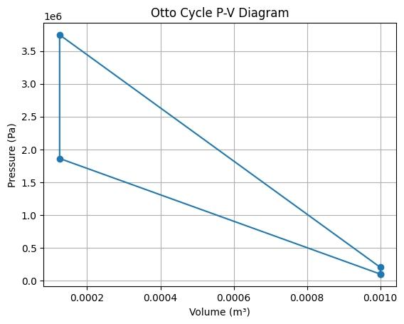

**Conclusion:**

The Thermodynamic Cycle Simulator successfully models and visualizes fundamental power and refrigeration cycles such as Otto, Brayton, and Rankine. By using Python with libraries like matplotlib and CoolProp, the simulator can generate P–V and T–S diagrams, calculate cycle efficiency, and analyze work and heat interactions.

Clear visualization of cycle processes, which enhances learning for students and helps engineers in preliminary analysis.

Extensibility to different working fluids (air, water, refrigerants), making it useful for diverse applications from IC engines to power plants and refrigeration systems.

Overall, the simulator bridges theory and practical application by transforming textbook equations into an educational software tool, encouraging deeper exploration into energy systems and thermal engineering.